Name: Ashutosh Arun Bagal

Internship project

Aim: Create a simple interface either in flask or django, which can accept payment from razorpay and stripe.

For API key generation first create an account on razorpay and generate a key and enter it into the code.

* For Razorpay

This is the home page where we have a button to pay with razorpay

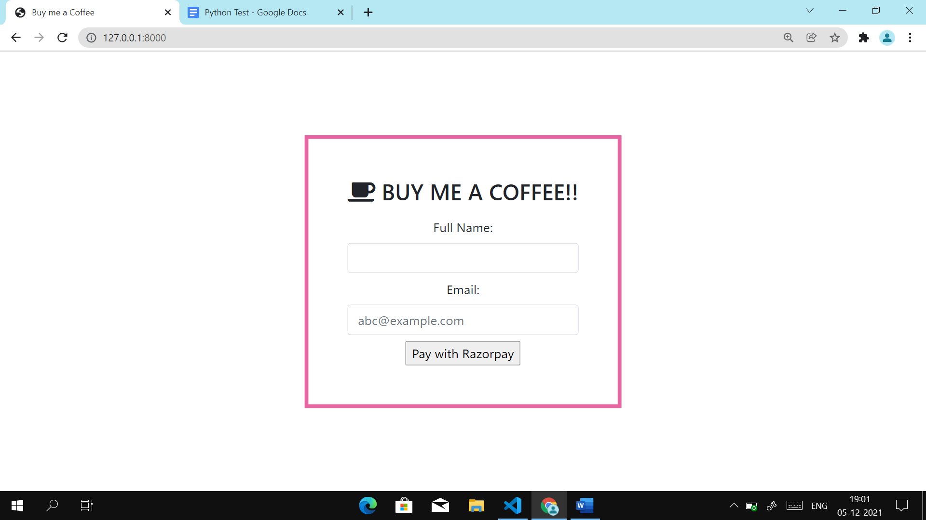

After clicking the button it will open a dialogue where user will enter his credentials.

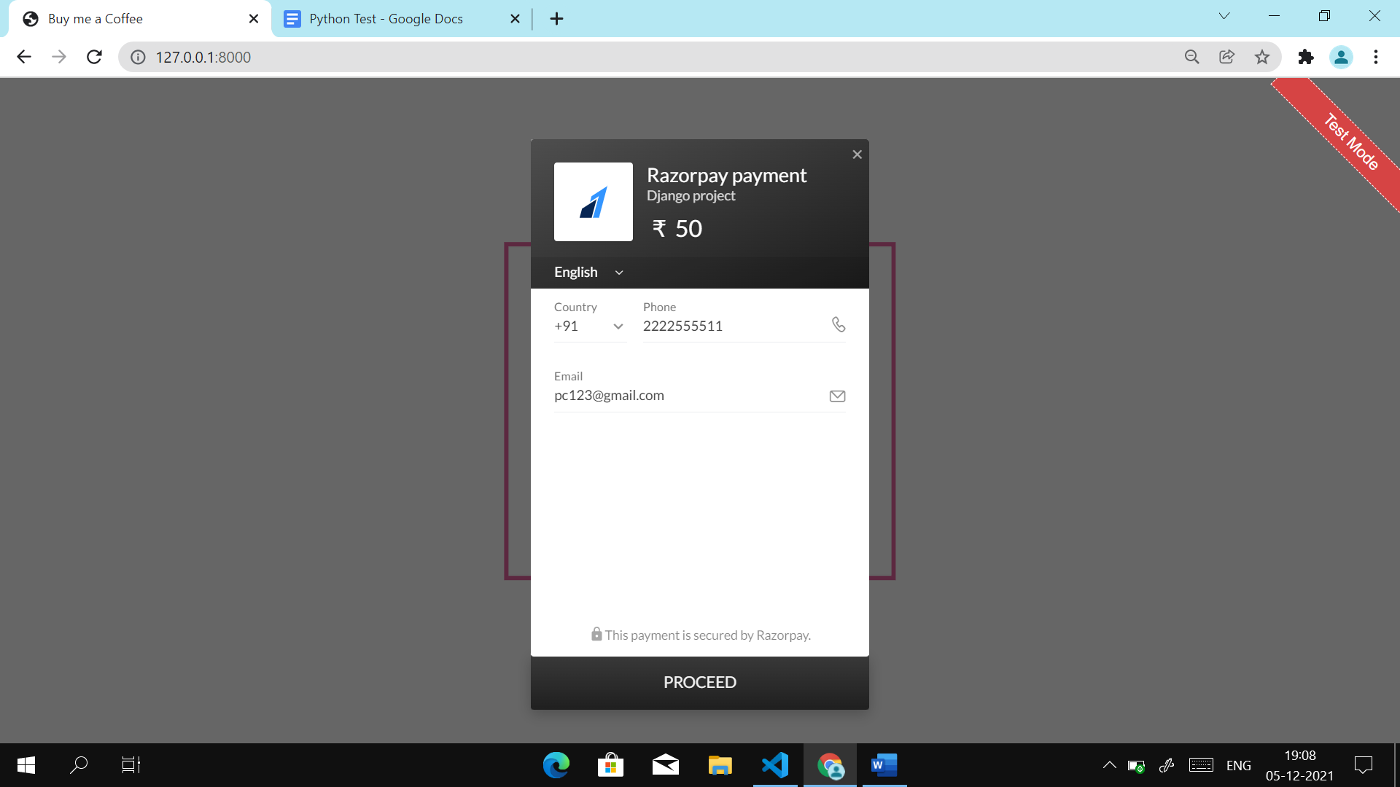

After clicking to proceed button, payment methods will be seen like card, UPI, google pay, phone pe etc

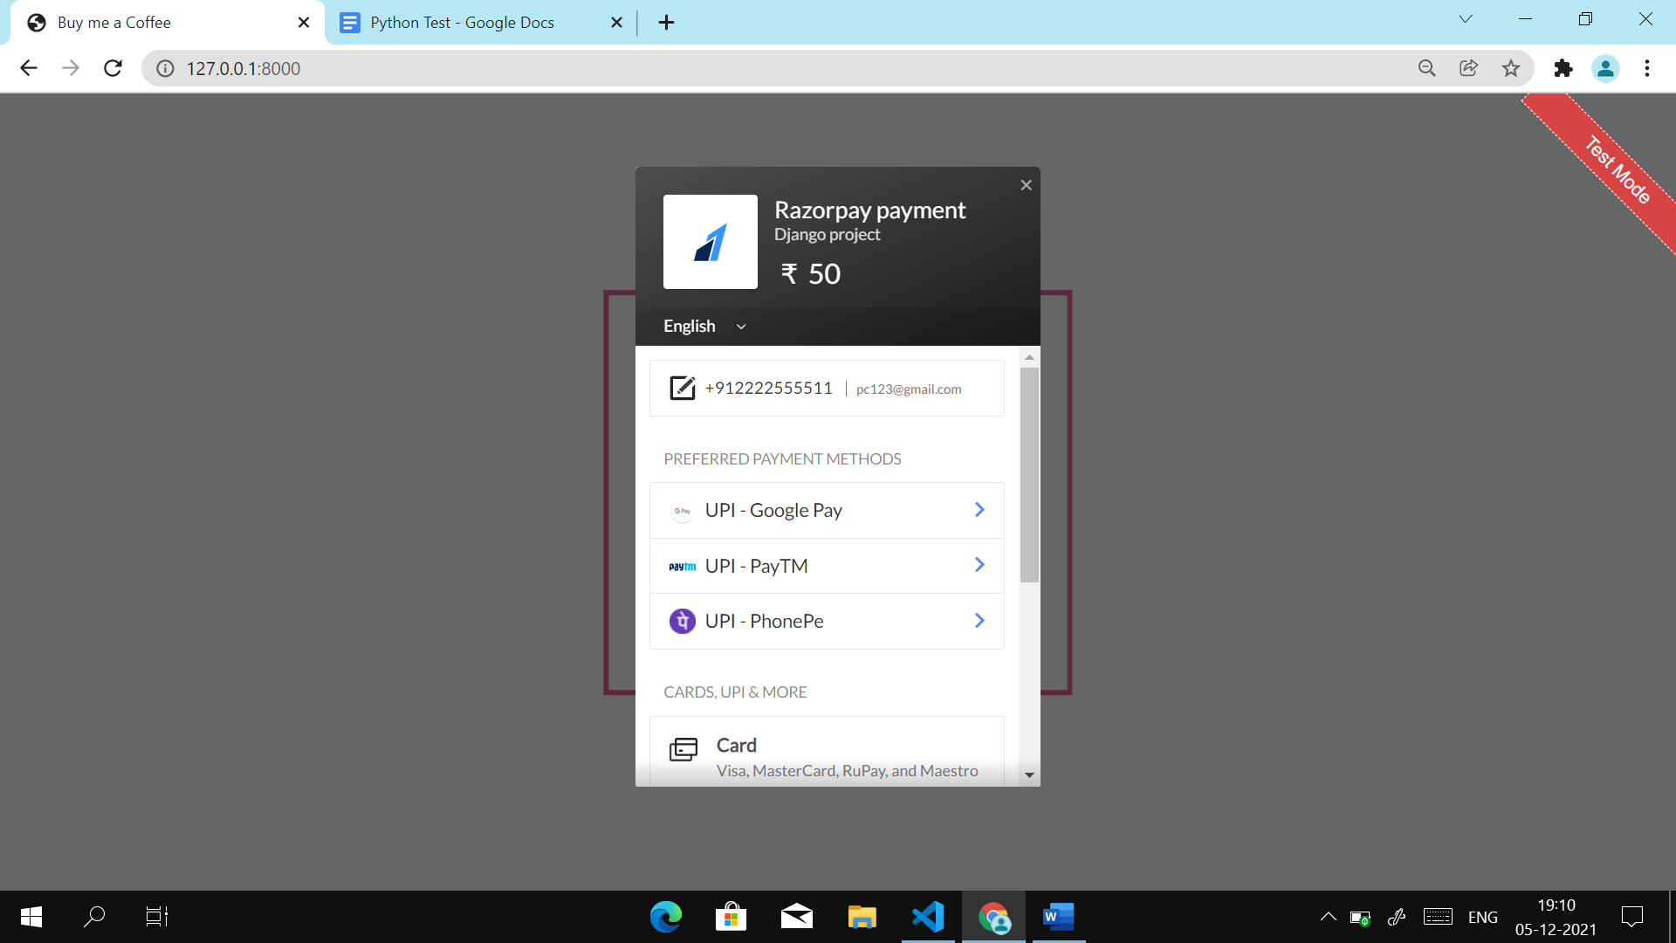

Here we have filled details of UPI ID and finally click on pay

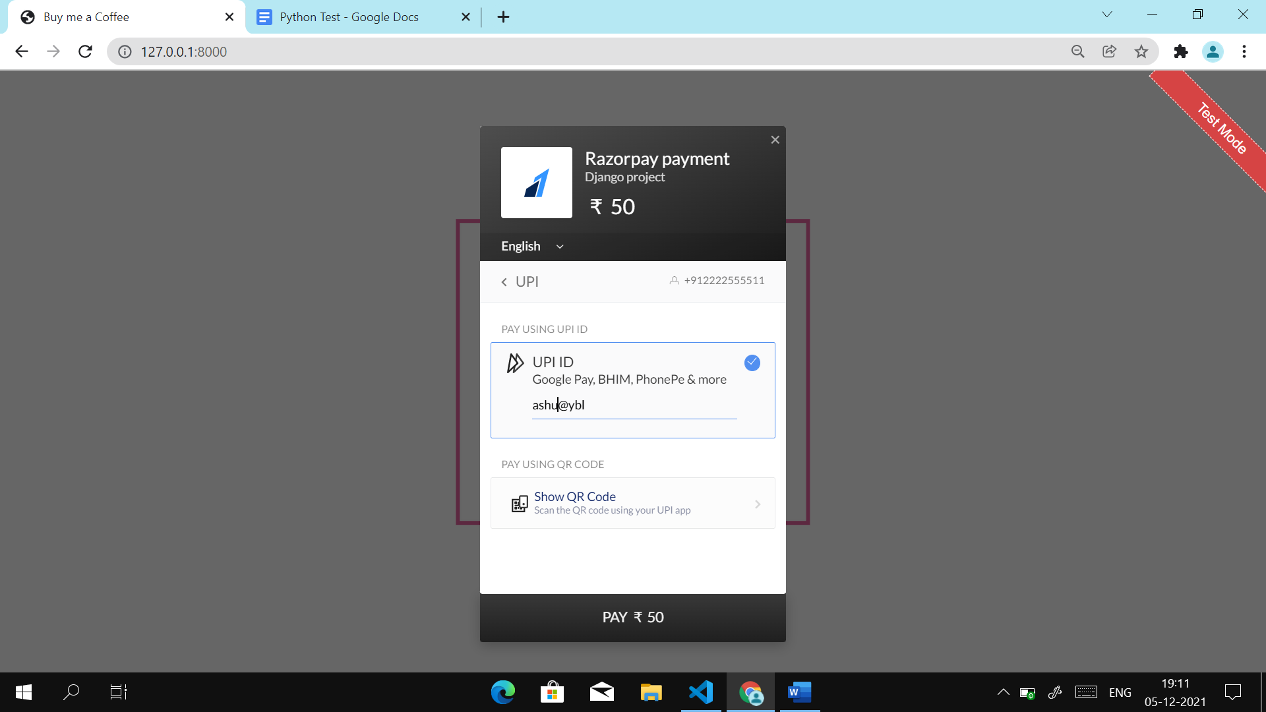

This is going process of payment.

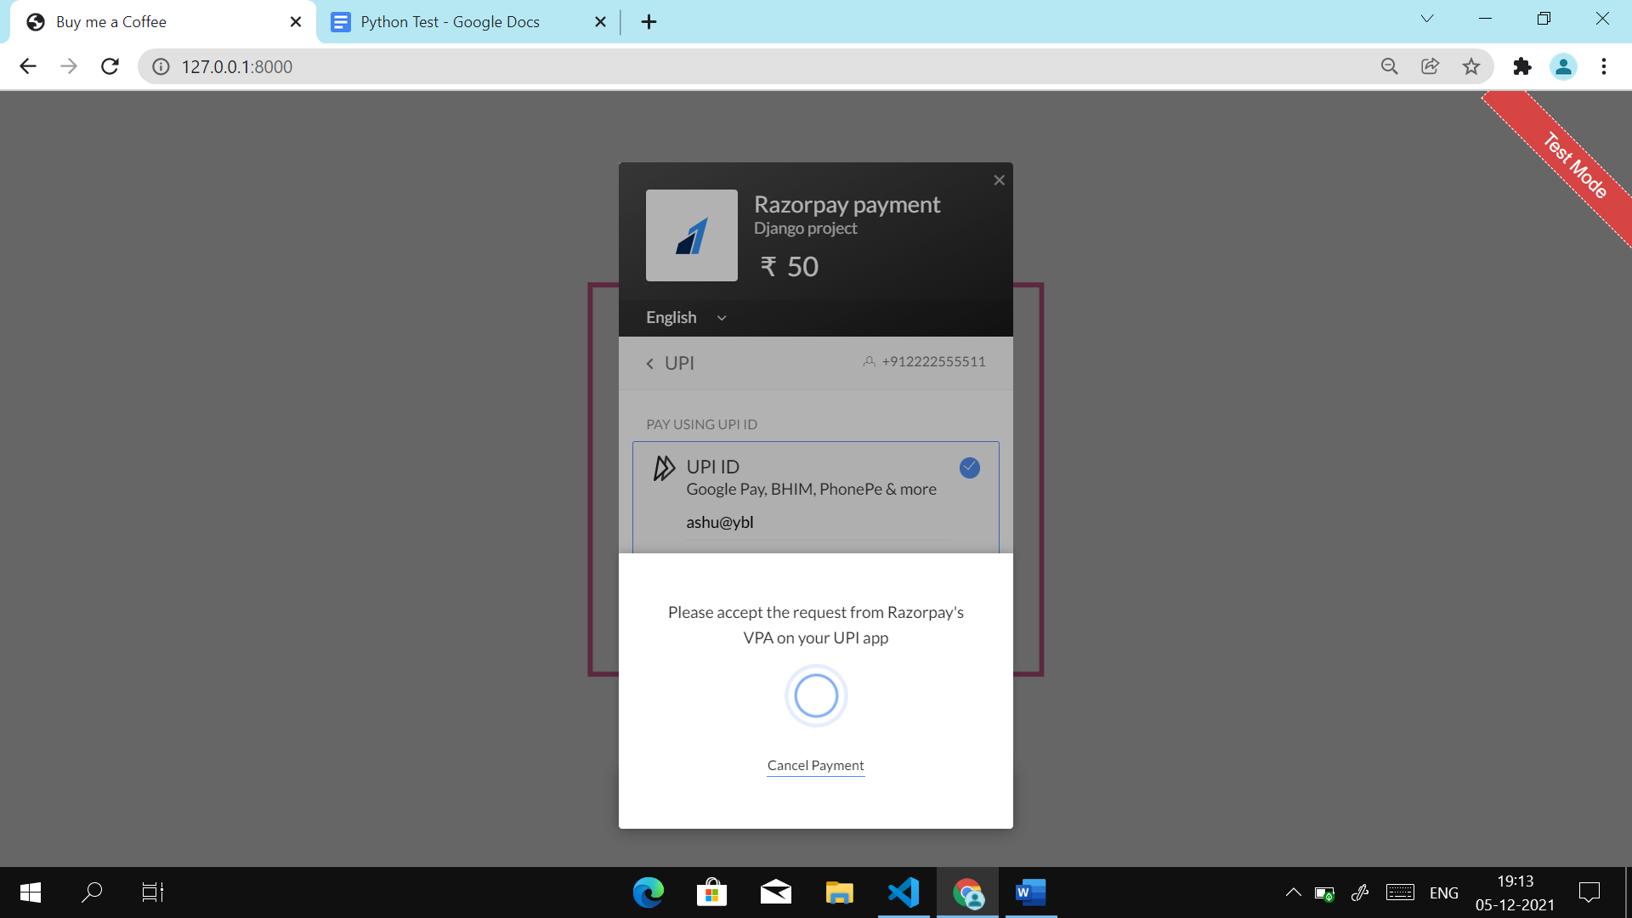

This is the success page after successful completion of payment.

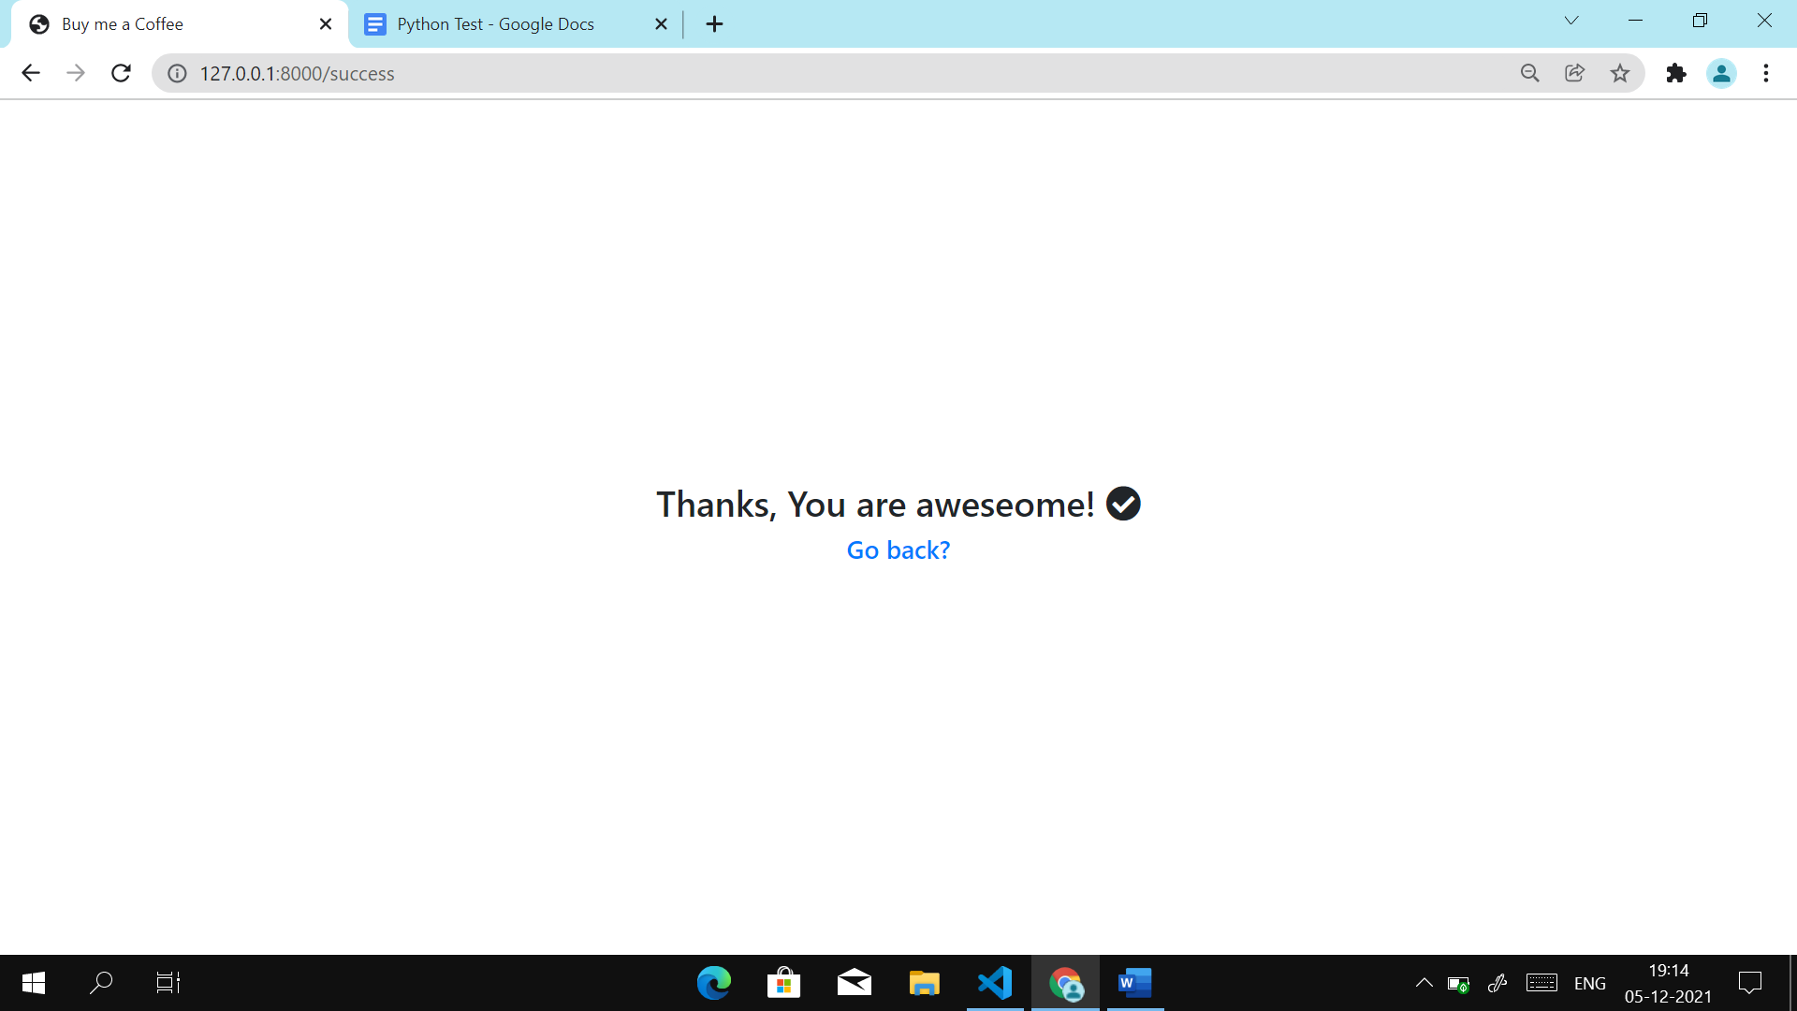

* For stripe

This is the home page where we have button for stripe.

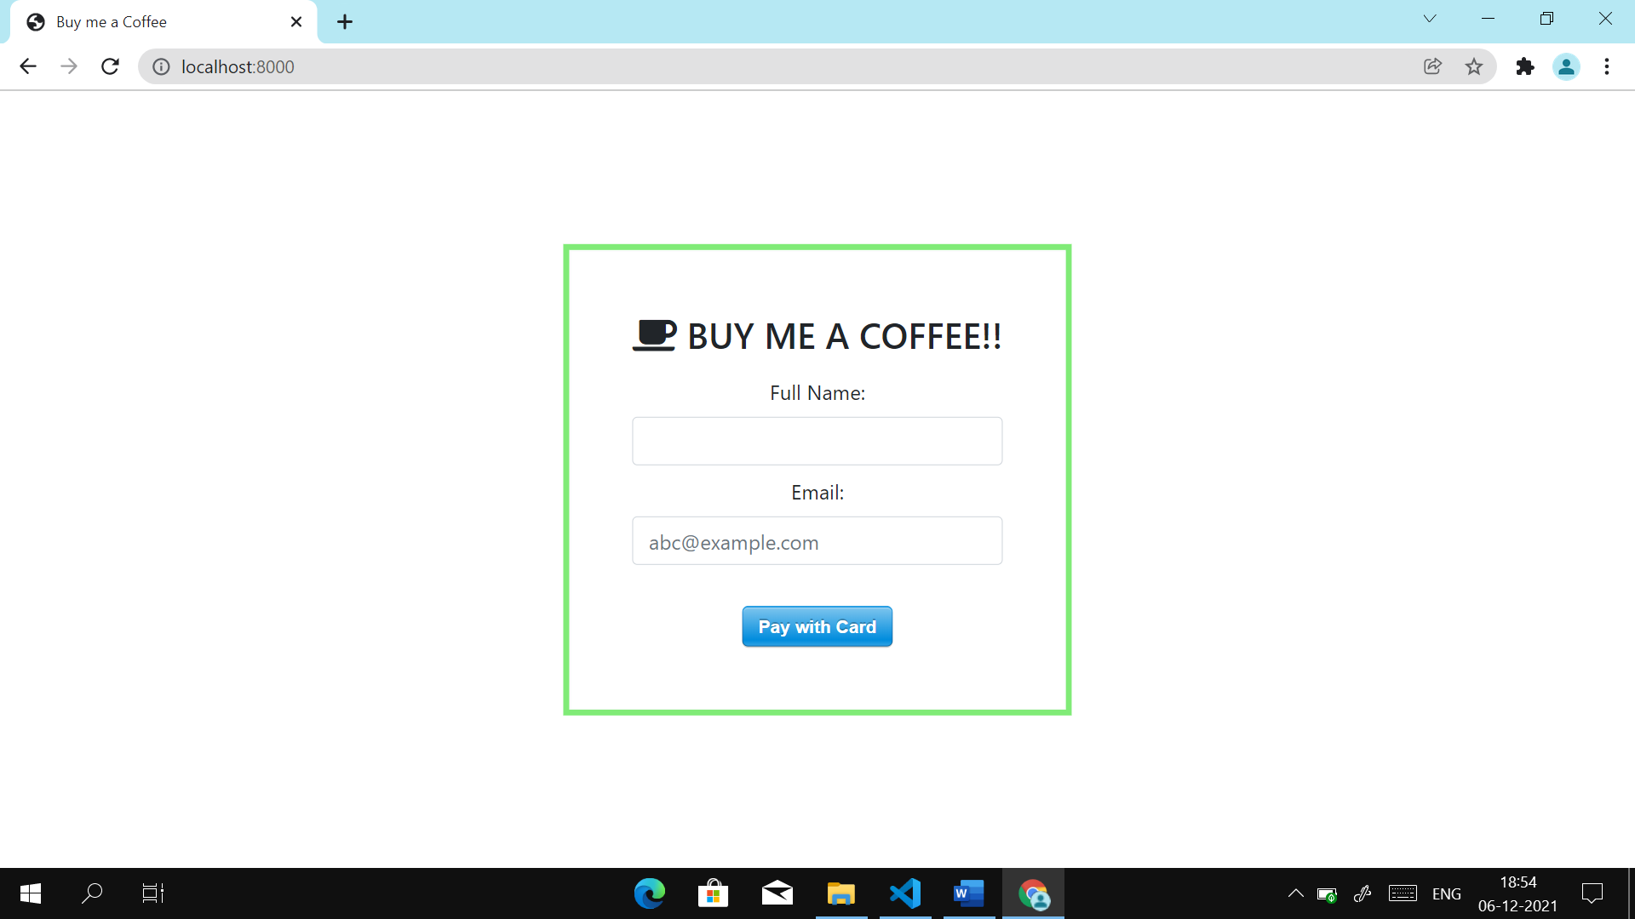

After clicking the button stripe dialogue box will appear, we have filled details.

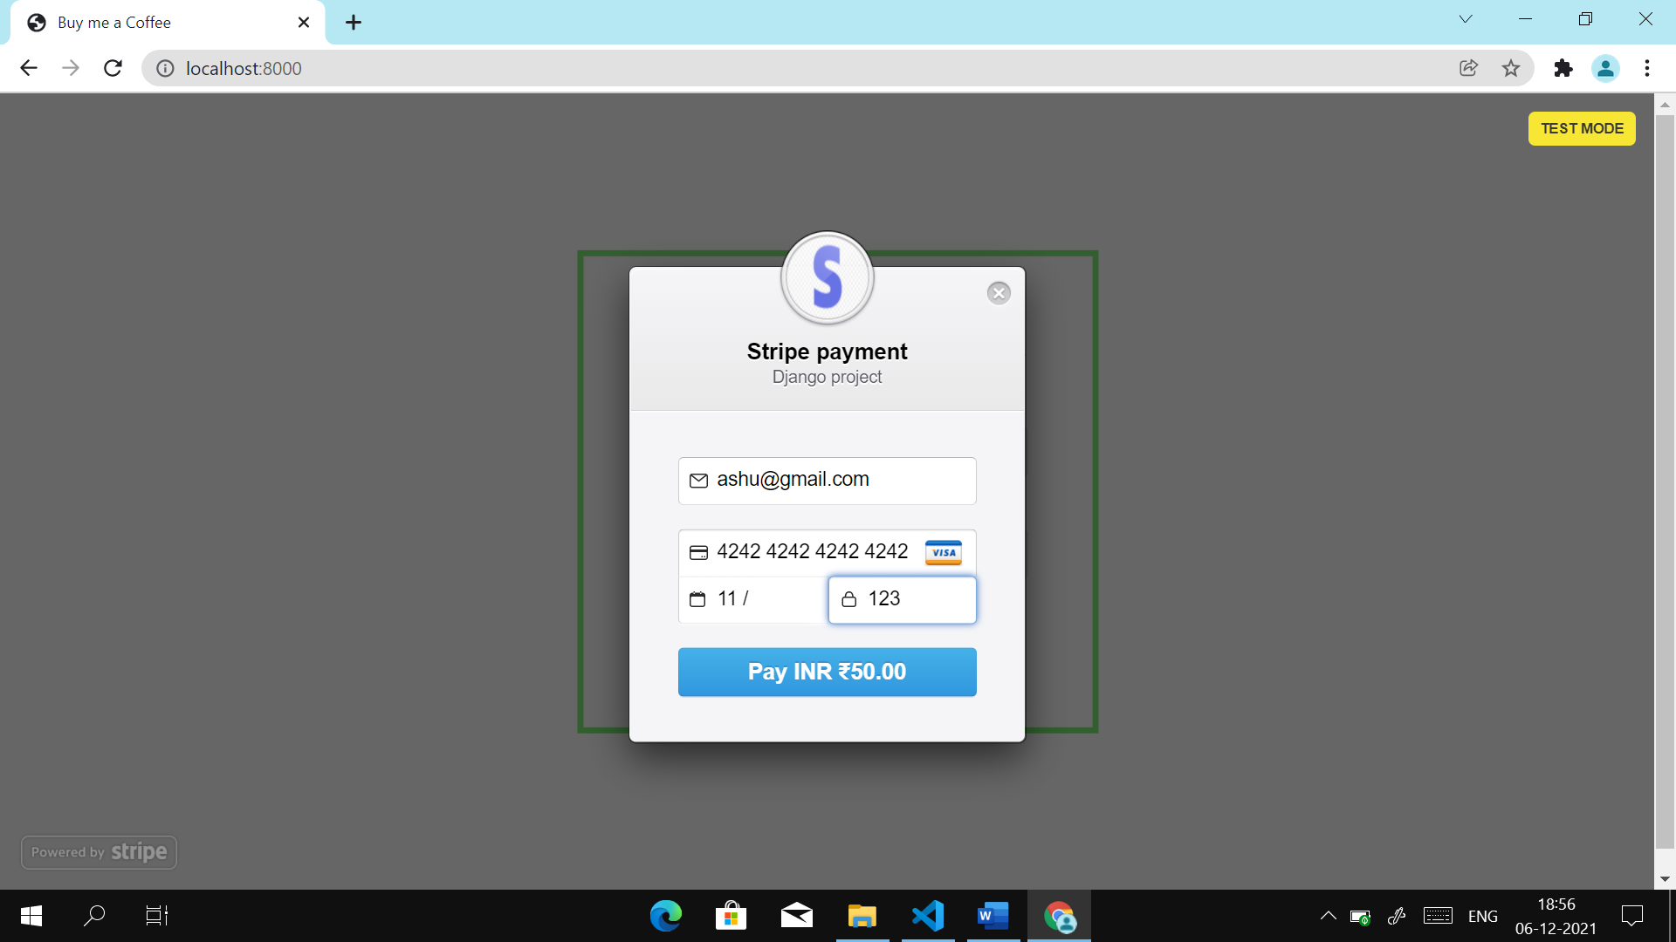

This is after clicking the pay button and after successful completion of payment.

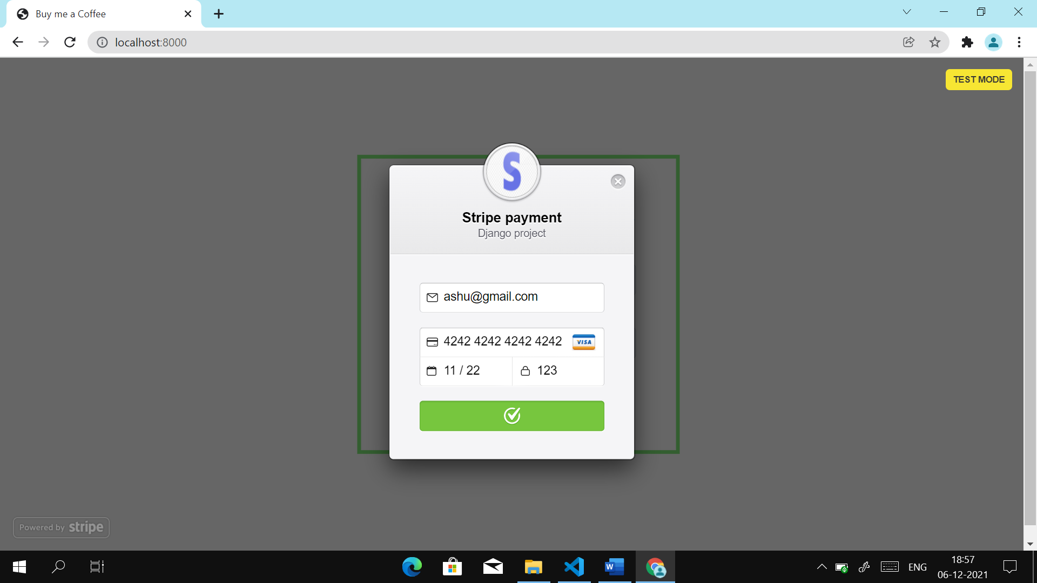

This is the success page after the payment.

